LECTURE 2
PROCESS

What is a Process?
- A program is a file stored on disk.
- When the program is executed, it becomes a process.
- The Operating System (OS) is responsible for running processes.
- Running the same program twice creates two different processes.

What is a Process? (Detailed)
A process consists of several important parts:
a) Process Identifier (PID)
- A unique number given to each process.
- Used by the OS to identify and manage processes.
b) Address Space (Memory Image)
Memory used by a process is divided into:
- Static memory
  - Program code
  - Global data
- Dynamic memory
  - Stack → stores function calls and local variables
  - Heap → stores dynamically allocated data
c) Context (VERY IMPORTANT)
Context is the CPU-related information that allows the OS to pause and resume a process correctly.
It includes:
Program Counter (PC)
- Stores the address of the next instruction to execute.
- Tells the CPU where to continue after a pause.
Without PC, the process wouldn’t know where to resume.
Stack Pointer (SP)
- Points to the top of the stack.
- Keeps changing during program execution.
- Moves when:
  - A function is called
  - Local variables are created
  - Data is pushed or popped from the stack
- Manages the current state of the stack.
Frame Pointer (FP)
- Points to the start (base) of the current function’s stack frame.
- Remains fixed while a function is running.
- Used to access:
  - Function parameters
  - Local variables
- Provides a stable reference inside a function.
Other Register Values
- Store temporary results and data.
- Must be saved so the process continues correctly.
d) Resources
- Files opened by the process (file descriptors)
- CPU time and other system resources
In short:
Process = PID + Memory + Context + Resources
4. Process Creation
When a new process is created, the Operating System performs these steps:
- Allocate memory
  - OS assigns memory space to the process.
- Create memory image
  - Loads code and data from disk.
  - Creates runtime stack and heap.
- Open files
  - Default files are opened:
    - stdin
    - stdout
    - stderr
- Initialize context
  - Sets initial values for:
    - Program Counter (PC)
    - Stack Pointer (SP)
    - Frame Pointer (FP)

Process States
A process state shows what a process is doing at a given time.
Main Process States
1. Running
- The process is currently using the CPU.
- Only one process can be running on a CPU at a time.
2. Ready
- The process is ready to run.
- It is waiting for CPU time.
3. Blocked (Waiting)
- The process cannot run right now.
- It is waiting for something, such as:
  - Input from keyboard
  - Data from disk
  - I/O operation to finish
Other States (in some OS)
- New → process is being created
- Dead (Terminated) → process has finished execution

Process State Transitions
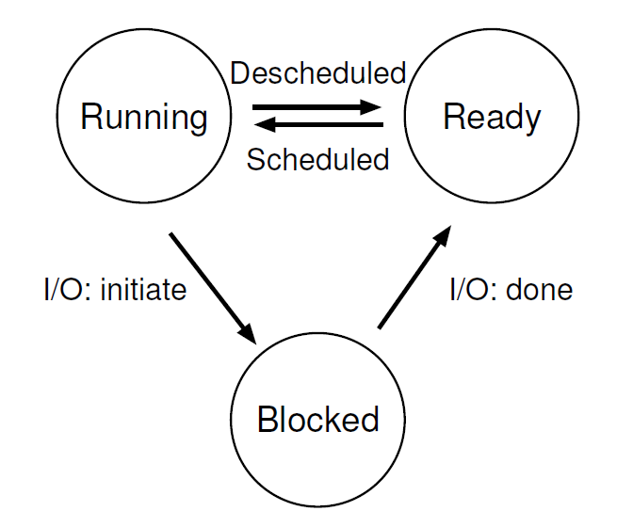
A state transition means a process moves from one state to another.
Common Transitions
- Ready → Running
  - CPU scheduler selects the process.
- Running → Ready
  - Process is interrupted (time slice over).
- Running → Blocked
  - Process requests I/O or waits for an event.
- Blocked → Ready
  - I/O operation completes or event occurs.

Process Implementation
Process implementation explains how the Operating System (OS) actually manages and controls processes internally.
The OS cannot manage processes just by name, so it uses data structures to store all process information.
How the OS Manages Processes
1. Process Lists
The OS keeps separate lists of processes based on their state, such as:
- Ready list → processes ready to use the CPU
- Blocked list → processes waiting for I/O or events
- Running process → the one currently using the CPU
This helps the OS quickly decide which process to run next.
2. Process Control Block (PCB)
Each process has a Process Control Block (PCB).
A PCB is a data structure that stores all important information about a process.
The OS uses the PCB to:
- Stop a process
- Resume a process
- Schedule a process
- Terminate a process
3. Information Stored in PCB
a) Process Identifier (PID)
- Unique number for each process.
- Used to identify the process.
b) Process State
- Shows current state:
  - Ready
  - Running
  - Blocked
  - Dead
c) Process Context
- Stores CPU information needed to resume execution.
- Includes:
  - Program Counter (PC)
  - Stack Pointer (SP)
  - Frame Pointer (FP)
  - CPU registers
d) Process Resources
- Files opened by the process
- CPU time used
- Memory allocated
e) Parent and Child Information
- Stores:
  - Parent process ID
  - Child process IDs

Parent and Child Process
A parent process is a process that creates another process, which is called a child process. When a child process is created, it is assigned a new process ID (PID), and the operating system keeps a record of the parent–child relationship. The parent process can control the child process and may also wait for it to finish its execution. If the parent process ends, the child process may either terminate or be taken over by another system process, depending on the operating system. For example, a shell acts as a parent process when it creates a program process as its child.

Process: Data Structures: (struct proc) *OPTIONAL
char *mem;
- Points to the start of the process’s memory.
- This is where the program code and data are stored.
uint sz;
- Stores the size of the process memory.
- Tells how much memory the process is using.
char *kstack;
- Points to the kernel stack of the process.
- Used when the process runs in kernel mode (system calls, interrupts).
enum proc_state state;
- Stores the current state of the process.
- Examples:
  - Ready
  - Running
  - Sleeping
  - Zombie
int pid;
- The Process ID (PID).
- A unique number for each process.
struct proc *parent;
- Points to the parent process.
- Used to maintain the parent–child relationship.
void *chan;
- Used when the process is sleeping.
- Stores the event or channel the process is waiting for.
int killed;
- Indicates whether the process has been marked for termination.
- If non-zero → process will be killed soon.
struct file *ofile[NOFILE];
- List of open files used by the process.
- Helps the OS track file usage.
struct inode *cwd;
- Stores the current working directory of the process.
- Used for file path operations.
struct context context;
- Stores CPU register values needed for context switching.
- Used when the OS switches between processes.
struct trapframe *tf;
- Stores CPU state during:
  - Interrupts
  - System calls
- Helps return correctly after an interrupt.

